Art Education Program Critical Assessment Art Lesson Plan and Artwork Sample
Directions:
1. Write a lesson plan that integrates Art with at least one other cooperating discipline (Math, Science, Language Arts, Social Studies, Music, Drama, Dance, etc.), using the format below. This is an art education course so the focus is on the art lesson with support from another discipline.
2. Create the Art work that is described in the lesson.
3. Refer to the Grading Rubric and assess your progress.
Please write the following headings and complete the information for each heading. You can remove the specific directions for each section and replace with your explanation for your lesson, but keep the headings/template.
Developing Teacher

Subject/Topic ____________________________ Grade Level __________

GUIDING QUESTIONS
Answer these questions as you build your lesson plan.

Enacted on the Spot
- What will I do to engage students in the lesson?

- What will I do to recognize and acknowledge lack of adherence to classroom rules and procedures?

- What will I do to communicate high expectations to students within the lesson?

- List the questions you will ask your students throughout the lesson, identifying high/low levels

Planning and Preparing for Use of Resources and Technology
How will the resources and materials that you select be used to enhance students' understanding of the content?
Please describe:
- traditional resources

- technology

Planning and Preparing for the Special Needs of Students
How do you plan to address the special needs of your students to include special education students, ELL students and students who come from home environments that offer little support for schooling?
Please describe:
- specific accommodations that will be made

Developing Teacher

Subject/Topic ____________________________ Grade Level __________

LESSON PLAN

Subject Matter Content
Select by checking either choice or both depending upon the lesson content:
Marzano Focus: ____ Introducing New Knowledge ___ Deepening/Practicing
Indicate what you intend to teach and identify concepts and skills that will be included in the lesson.
- Full description of the Forms of Knowledge (concept, skill)
List the concepts/skills in visual art production, art criticism, art history, aesthetics and the cooperating discipline that you have selected for this lesson.
(Keep these headings in your lesson plan)
  - Visual Arts Concepts/Skills
    - Art Criticism
    - Art History
    - Aesthetics
    - Art Production
  - Cooperating Discipline Concepts/Skills (this is where you list the skills/concepts for: Math, Language Arts, Science, Social Studies, etc.)
- Vocabulary- New vocabulary words and their definitions for visual art and at least one cooperating discipline you selected to integrate with visual arts (for example: Math, Language Arts, Science, Social Studies, Music, Drama, etc.).
  - Visual Art Vocabulary and Definitions
  - Cooperating Discipline Vocabulary and Definitions

Instructional Objectives/Outcomes
Indicate what is to be learned. Include the following objectives and goals: Ask yourself, "What do I want my students to know and be able to do at the end of the lesson and how will I measure that this was achieved?"
- Specific Lesson Objectives (Written as a SMART Objective linked to the assessment)
Specific:
Measureable:
Action:
Resources:
Time:
- Florida Next Generation Standards & Grade Level Expectations (use the appropriate codes and descriptions for only standards assessed in this lesson) and the Florida Standards
- 3 standards/benchmarks from different BIG IDEAS for Visual Arts for the selected grade level. There are five Big Ideas in visual art: (these are copied from third grade in CPALMS website)
Big Idea VA.3.C: Critical Thinking and Reflection

Big Idea VA.3.H: Historical and Global Connections

Big Idea VA.3.F: Innovation, Technology, and the Future

Big Idea VA.3.O: Organizational Structure

Big Idea VA.3.S: Skills, Techniques, and Processes
Once you select the three areas click on the titles to select the Enduring Understanding. Then click on the title of the Enduring Understanding to select the specific benchmarks for the lesson.
- 2 standards from another content area (discipline). For example, if integrating visual art with language arts you would select two language arts Florida Standards for the grade level.
- Level of complexity for the lesson: This is based upon New Bloom’s Taxonomy and the Marzano Taxonomy. For Broward County Schools use Webb’s Depth of Knowledge.
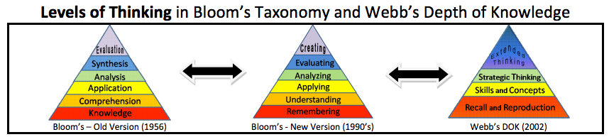
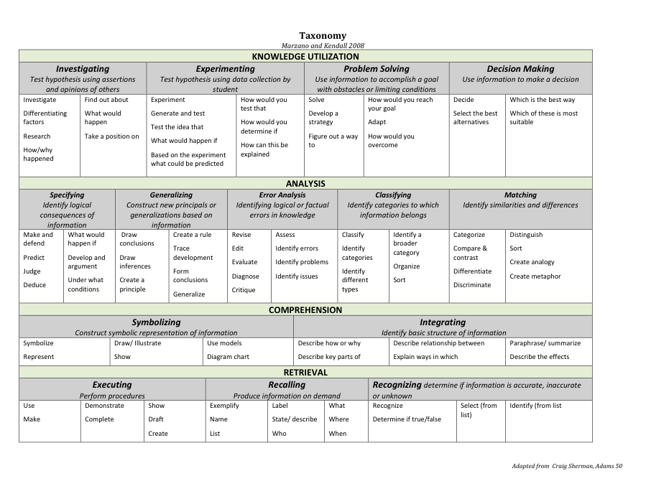
- Goal 3 Standards (List appropriate standards and describe the activities provided for students in this lesson that demonstrate the Goal 3 standards)
Copy and Paste to your lesson plan- Standard 4: Florida students use creative thinking skills to generate new ideas, make the best decision, recognize and solve problems through reasoning, interpret symbolic data, and develop efficient techniques for lifelong learning.

Learning Targets: (write in the scale below) TIP: Remember this is a progression of learning.
4.0 Cognitively Complex: In depth inferences or applications that go deeper with the standard

3.0 Learning Goal: Essential knowledge and skills required to demonstrate mastery of the
STANDARD TIP: This is where the standard(s) is copied/pasted.

2.0 Foundational: Knowledge integrated with basic processes that provide the foundation
necessary to reach the Learning Goal Targets

1.0 With help from the teacher, student has partial success with content.

Monitoring (checks for content and desired effect)
How will you know where the students are on the scale?

Instructional Procedures
Indicate how you intend to sequence the activities in the lesson from initiation to closure, estimating the time necessary to complete each major component of the lesson.

Lesson Initiating Activity (the “hook”):
Time:_____
Write a brief description of an activity that will start off your lesson. Introduce an artist and their work here. Give a brief paragraph about the artist that you would share with the students (art history). Have students discuss the artwork through art criticism and aesthetics.
Core Instruction:
Time:____
Please note that you must explain how to make the art project and use the specific art media you have selected for this lesson. This is the "hands on" portion of the lesson.
Closure Activity:
How will you end the lesson? What ideas will students leave the classroom pondering? Assessment procedures should be implemented here. Include clean up procedures for studio projects.
Time: ____

Delivery of Instruction
Evidence of higher order questioning practices: provide examples of several levels of appropriate, content specific questions you plan to pose to your students during the lesson. One question per level minimum. These must be art related questions for the art lesson.
1. Level 2-Understanding:
2. Level 3- Applying:
3. Level 4- Analyzing:
4. Level 5-Evaluating:
5. Level 6-Creating:

Artwork Sample: Attach your jpg. file of your artwork sample. This is very important to include as it is worth 25 points of the final grade.

Assessment/Evaluation
Assessment/Evaluation: Identify the assessment strategies used in determining to what extent the students have attained the instructional objective(s). For example, tests, presentations, products and/or systematic observation (attach copy of the sample test if used). Assessment techniques must include measurable terms and link to the SMART objective and performance outcomes, (criteria level).
Include a rubric and explain how assessment is conducted. For example, assessment is conducted through teacher observation during studio time, student self-assessment after completion of project, group critique at end of project, etc. The criteria for the rubric must match the Sunshine State Standards and objectives for your lesson. You must assess the visual art content as well as the content from the other cooperating discipline.

Follow-up Activities

Follow-up Activities: Indicate how other activities/materials are used to remediate, reinforce, and extend this lesson to assist with differentiated instruction. Include special assignments, projects, field trips, research, technology, etc.

References/Bibliography

List what resources or books/articles/videos, etc. that you used to create the lesson. Including any online sources including lesson ideas/plans that you found online. This includes our class textbook, Art Integration in the Schools.

